KHALLAL-SHINDE CHEMISTRY CLASSES
Time: 35 min Coordination Compounds Marks: 30
Dt: 01/02/21

- The correct order of increasing reactivity of C-X bond towards nucleophile in the following compounds is
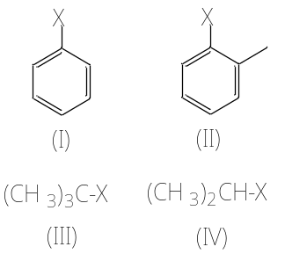
a) I < II < III < IV b) II < I < III < IV
c) III < IV < II < I d) IV < III < I < II

- 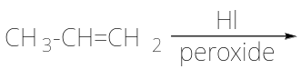
The major product of the above reaction is,
a) I-CH₂-CH=CH₂ b) CH₃-CH₂-CH₂I
c) 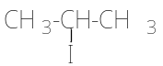 d) 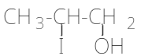

- Which of the following is likely to undergo racemization during alkaline hydrolysis?
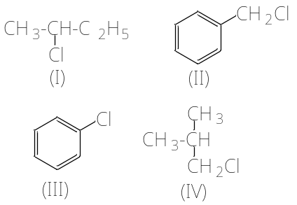
a) Only I b) Only II
c) II and IV d) Only IV

- The best method for preparation of alkyl fluorides is
a) Finkelstein reaction
b) Swartz reaction
c) Free radical fluorination
d) Sandmeyer’s reaction

- Identify the chiral molecule form the following
a) 1-Bromobutane
b) 1, 1-Dibromobutane
c) 2, 3-Dibromobutane
d) 2-Bromobutane

- An alkyl chloride on Wurtz reaction gives 2, 2, 5, 5-tetramethylhexane. The same alkyl chloride on reduction with zinc-copper couple in alcohol give hydrocarbon with molecular formula C₅H₁₂. What is the structure of alkyl chloride
a) 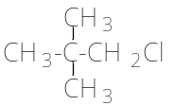 b) 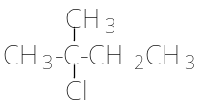
c) 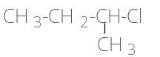 d) 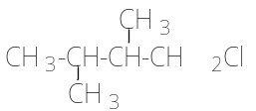

- Butanenitrile may be prepared by heating
a) Propanol with KCN
b) butanol with KCN
c) n-butyl chloride with KCN
d) n-propyl chloride with KCN

- Choose the compound from the following that will react fastest by S_{N}1 mechanism
a) 1-iodobutane
b) 1-iodopropane
c) 2-iodo-2 methylbutane
d) 2-iodo-3-methylbutane

- 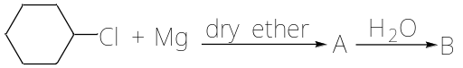
The product ‘B’ in the above reaction sequence is,
a) 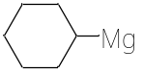 b) 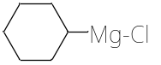
c) 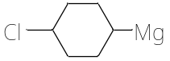 d) 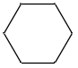

- Which of the following is used as source of dichlorocarbene
a) tetrachloromethane b) chloroform
c) iodoform d) DDT

- IUPAC name of 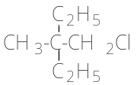is
a) 1-chloro-2, 2-diethylpropane
b) 3-chloro-2, 2-diethylpropane
c) 1-chloro-2-ethyl-2-methylbutane
d) 1-chloro-2, 2-diethyl-2-methylethane

- How many isomers are possible for compounds having the molecular formula C₅H₁₁Br?
a) nine b) eight
c) six d) seven

- Which of the following alkane formed halides in good yield on monohalogenation?
a) Butane b) Propane
c) Isobutane d) Neopentane

- Reagent used in Finkelstein reaction is
a) NaI in dry acetone
b) HI in dry acetone
c) NaOI in dry acetone
d) NaI in dry ether

- Ethyl bromide can be obtained by the action of HBr on
a) ethane b) propene
c) ethene d) acetylene

- Conversion of CH₄ to CH₃Cl is a example of which of the following reactions?
a) Free radical addition
b) Free radical substitution
c) Nucleophilic substitution
d) Electrophilic substitution

- Which among the following has highest boiling point
a) 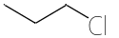 b) 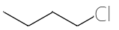
c) 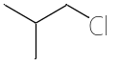 d) 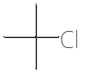

- What is A 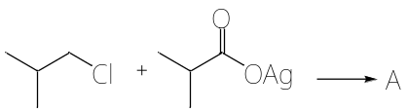
a) 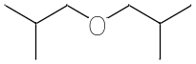 b) 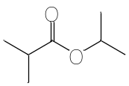
c) 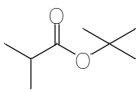 d) 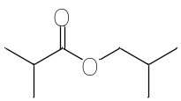

- The product formed in highest yield in the following reaction is,
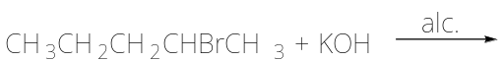
a) CH₃CH₂CHOHCH₂CH₃
b) CH₃CH₂CH₂CH=CH₂
c) CH₃CH₂CH₂CH₂OH
d) CH₃CH₂CH=CHCH₃

- Ethane nitrile is obtained by the reaction of following
a) CH₃Br + KCN b) C₂H₅Br + KCN
c) CH₃Br + AgCN d) C₂H₅Br + AgCN

- Propanenitrile is obtained by the action of alcoholic KCN and what?
a) CH₃Cl b) C₂H₅Cl
c) (CH₃)₂CHCl d) C₂H₅OH

- The following alkyl halides in the decreasing order of SN² reactivity is,
(1) (CH₃)₃CCl (2) CH₃Br
(3) CH₃Cl (4) (CH₃)₂CHCl
a) 1>2>3>4 b) 2>3>4>1
c) 3>2>4>1 d) 2>3>1>4

- Markownikoffs rule provides guidance of addition of HX on
a) CH₂=CH₂ b) CH₃CH=CHCH₃
c) CH₃CH=CH₂ d) CH₃CHO

- The halogen which is most reactive in the halogenation of alkane under diffused sunlight is,
a) fluorine b) bromine
c) chlorine d) iodine

- In the elimination reaction of ethyl halide carbon atom change its hybridisation is,
a) sp² to sp³ b) sp³ to sp
c) sp³ to sp² d) sp to sp³

- β-elimination of 1-halo-3-methyl butane gives
a) 2-methyl but-2-ene
b) 3-methyl but-1-ene
c) 2-methyl propene
d) 2-methyl butan-2-ol

- The shape of methyl carbocation is likely to be
a) tetrahedral b) pyramidal
c) planar d) linear

- Which of the following species is an electrophile?
a) H₂O b) NH₃
c) R-O-H d) CH₃⁺

- Which of the following compound is optically active
a) C₂H₅-OH b) (CH₃)₂CHCH₂-Cl
c) CH₃-CHClC₂H₅ d) CCl₂F₂

- Which of the following is used as dry cleaning?
a) CHCl₃ b) CH₂Cl₂
c) CCl₄ d) CHI₃

- The
- Which 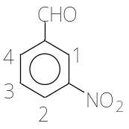
a) 1

